PO No. |  | Date: 09/11/2026

Supplier Name: VIS Marketing | Payment Terms
Address: Tacloban City | ☐ Credit
Contact Person: | ☐ Cash
Contact Number: | ☐ Check

Item Description | Quantity | Unit Price | Total Amount
Bearing 02474-20 | 1 pc | 750.00 | 750.00
Bearing 3579/3525 | 1 pc | 1,500.00 | 1,500.00
 | Total Amount |  | 2,250.00

Remarks
For REF VAN Plate No. NKG 9494

Prepared By: |  | Approved By:
__________ Vincent Mercader________  Mechanic |  | ______ __ Queben Johnson Coquilla__________  General Manager
PO No. |  |  | Date: 09/04/2026

Supplier Name: HINO TACLOBAN | Payment Terms
Address: Tacloban City | ☐ Credit
Contact Person: | ☐ Cash
Contact Number: | ☐ Check

Item Description | Quantity | Unit Price | Total Amount
Fuel Filter | 3 pcs
 | Total Amount

Remarks
For REF Van Plate No. DBA 3719

Prepared By: | 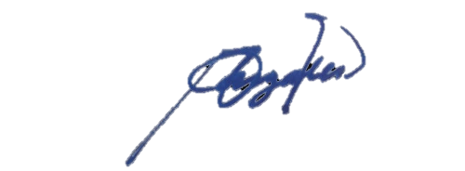  Approved By:
__________ Vincent Mercader________  Purchasing Staff | _____ Rowel Gonzales _______  Motorpool Manager

